МИНОБРНАУКИ РОССИИ

Федеральное государственное бюджетное образовательное

учреждение высшего образования

"Ижевский государственный технический университет имени М.Т.Калашникова"

(ФГБОУ ВО «ИжГТУ имени М.Т.Калашникова»)

Кафедра «Программное обеспечение»

Лабораторная работа №1

Верстка интерактивного шаблона сайта

Выполнил: студент группы

Б03-191-1зт

Полигаев Д.К.

Проверил: ст. преподаватель

Еланцев М.О.

Ижевск 2020г.

1. Постановка задачи

1. Сверстать сайт используя блочную верстку;

2. Сделать сайт адаптивным (мобильная и ПК версии);

3. Добавить на сайт два интерактивных элемента (можно использовать плагины jquery).

|  |  |  |  |  |  |  |  |
| --- | --- | --- | --- | --- | --- | --- | --- |
| **Вариант** | Номер рисунка | | | | | Интерактивные элементы | |
| Фон | Шапка | Меню | Содержимое | Подвал | Первый | Второй |
| **11** | 1 | 4 | 1 | 1 | 1 | Галерея | Кнопка «Вверх» |

Для верстки мобильной версии использовать рисунок 6.

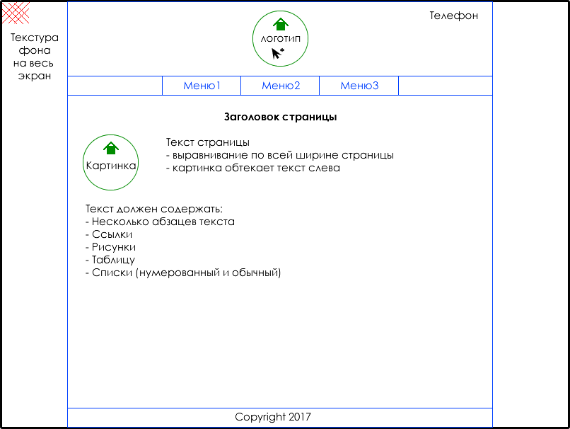

Рис. 1

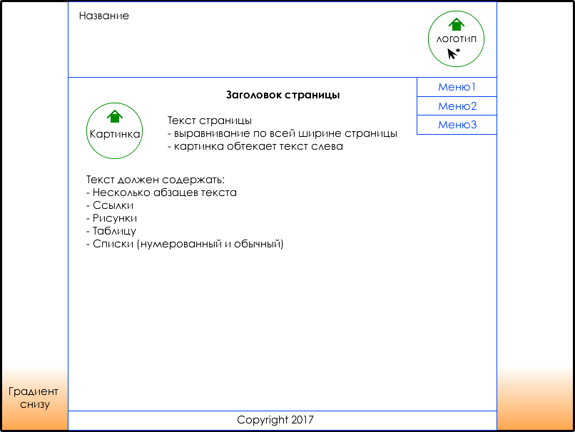

Рис. 3



Рис. 6

2. Код сайта

Файл index.html

<!DOCTYPE html>

<html lang="en">

<head>

<meta charset="UTF-8">

<meta name="viewport" content="width=device-width, initial-scale=1.0">

<title>Gallery</title>

<link rel="stylesheet" href="style.css">

<script type="text/javascript" src="./scripts/jquery-1.4.3.min.js"></script>

<script type="text/javascript" src="./scripts/fancybox/jquery.mousewheel-3.0.4.pack.js"></script>

<script type="text/javascript" src="./scripts/fancybox/jquery.fancybox-1.3.4.pack.js"></script>

<link rel="stylesheet" type="text/css" href="./scripts/fancybox/jquery.fancybox-1.3.4.css" media="screen" />

</head>

<body>

<div class="wrapper_background">

<header class='header'>

<div class='header__name-wrapper'>

<h3 class='header__name'>Gallery</h3>

</div>

<div class='header__logo-wrapper'>

<a href="./index.html">

<img src="./img/logo.jpg" alt="logo" class='header__logo' width="110" height="80">

</a>

</div>

</header>

<div class='menu__wrapper'>

<ul class='menu'>

<li class='menu__item current__menu'><a href="index.html">Главная</a></li>

<li class='menu__item'><a href="gallery.html">Галерея</a></li>

<li class='menu__item'><a href="gallery.html">Комментарии</a></li>

</ul>

</div>

<main class='content'>

<div class='content__wrapper clearfix'>

<div class="content__header"><h2 class="content__header-text">Заголовок страницы</h2></div>

<div class="content__text-wrapper clearfix">

<img src="./img/avatar.jpg" alt="text_picture" class="content__img">

<div class="content__text"><p>Modern times have been witness to a magnificent and accelerated evolutionary process. Ever since Moore’s law began to rule mankind, innovation has been a ubiquitous feature of the brave new world, and powerful technologies becoming readily available has been the norm for decades now. We have almost reached a point wherein further development is almost unnecessary—the tasks that most people engage in on a day to day basis have been polished and perfected on modern devices and interfaces as to require little reinventing due to already being so optimized.</p>

<p>The single driving engine behind most change now is visual capabilities. Showing off images and videos in ever-increasing quality and designed to be displayed on ever more demanding screens and resolutions drive developers to innovate, with creative new ways to handle powerful media formats and present them to the public at large in a candid, attractive, professional and engaging visual presentation. Gallery websites are among the oldest on the internet and also among the most continuously renovated, precisely due to this technological pressure to keep up with modern times and image quality standards. The following collection of HTML5 website templates has been selected with the criteria of outstanding Gallery designs, options or layouts. Enjoy.</p>

<a href="gallery.html">Галерея</a>

<p>The power you feel once you decide to go with Jevelin makes you feel comfortable enough to launch just about whatever page you would like. Due to Jevelin’s multi-purpose approach, it is safe to say that the tool can also be considered a gallery website template. It has all the assets, the characteristics and many extras to create a unique website for your photo project.</p>

<p>Bring your first-class works to the online audience and let everyone access it. Warning: you might see your inbox get flooded with new business proposals. Everything you do with Jevelin looks just so cutting edge it is hard for people not to get in touch and work with you. Give yourself the chance to stand out on the world wide web and become the succeeder you always wanted to be.</p>

<ol>

<li>список нумерованный</li>

<li>список нумерованный</li>

<li>список нумерованный</li>

</ol>

<ul>

<li>список обычный</li>

<li>список обычный</li>

<li>список обычный</li>

</ul>

<img src="./img/img1.jpg" alt="text_picture" class="content__text-img">

<img src="./img/img2.jpg" alt="text_picture" class="content__text-img">

<img src="./img/img3.jpg" alt="text_picture" class="content__text-img">

<table border="1">

<caption>Таблица размеров обуви</caption>

<tr>

<th>Россия</th>

<th>Великобритания</th>

<th>Европа</th>

<th>Длина ступни, см</th>

</tr>

<tr><td>34,5</td><td>3,5</td><td>36</td><td>23</td></tr>

<tr><td>35,5</td><td>4</td><td>36⅔</td><td>23–23,5</td></tr>

<tr><td>36</td><td>4,5</td><td>37⅓</td><td>23,5</td></tr>

<tr><td>36,5</td><td>5</td><td>38</td><td>24</td></tr>

<tr><td>37</td><td>5,5</td><td>38⅔</td><td>24,5</td></tr>

<tr><td>38</td><td>6</td><td>39⅓</td><td>25</td></tr>

<tr><td>38,5</td><td>6,5</td><td>40</td><td>25,5</td></tr>

<tr><td>39</td><td>7</td><td>40⅔</td><td>25,5–26</td></tr>

<tr><td>40</td><td>7,5</td><td>41⅓</td><td>26</td></tr>

<tr><td>40,5</td><td>8</td><td>42</td><td>26,5</td></tr>

<tr><td>41</td><td>8,5</td><td>42⅔</td><td>27</td></tr>

<tr><td>42</td><td>9</td><td>43⅓</td><td>27,5</td></tr>

<tr><td>43</td><td>9,5</td><td>44</td><td>28</td></tr>

<tr><td>43,5</td><td>10</td><td>44⅔</td><td>28–28,5</td></tr>

<tr><td>44</td><td>10,5</td><td>45⅓</td><td>28,5–29</td></tr>

<tr><td>44,5</td><td>11</td><td>46</td><td>29</td></tr>

<tr><td>45</td><td>11,5</td><td>46⅔</td><td>29,5</td></tr>

<tr><td>46</td><td>12</td><td>47⅓</td><td>30</td></tr>

<tr><td>46,5</td><td>12,5</td><td>48</td><td>30,5</td></tr>

<tr><td>47</td><td>13</td><td>48⅔</td><td>31</td></tr>

<tr><td>48</td><td>13,5</td><td>49⅓</td><td>31,5</td></tr>

</table>

<p></p>

</div>

</div>

</div>

</main>

<footer class='footer'>

<p>&copy; Copyright 2020</p>

</footer>

</div>

</body>

</html>

Файл gallery.html

<!DOCTYPE html>

<html lang="en">

<head>

<meta charset="UTF-8">

<meta name="viewport" content="width=device-width, initial-scale=1.0">

<title>Gallery</title>

<link rel="stylesheet" href="style.css">

<script type="text/javascript" src="./scripts/jquery-1.4.3.min.js"></script>

<script type="text/javascript" src="./scripts/fancybox/jquery.mousewheel-3.0.4.pack.js"></script>

<script type="text/javascript" src="./scripts/fancybox/jquery.fancybox-1.3.4.pack.js"></script>

<link rel="stylesheet" type="text/css" href="./scripts/fancybox/jquery.fancybox-1.3.4.css" media="screen" />

<script type="text/javascript">

$(document).ready(function(){

$("a.photo").fancybox({

transitionIn: 'elastic',

transitionOut: 'elastic',

speedIn: 500,

speedOut: 500,

hideOnOverlayClick: false,

titlePosition: 'over'

});

});

</script>

</head>

<body>

<div class="wrapper_background">

<header class='header'>

<div class='header__name-wrapper'>

<h3 class='header__name'>Gallery</h3>

</div>

<div class='header__logo-wrapper'>

<a href="./index.html">

<img src="./img/logo.jpg" alt="logo" class='header__logo' width="110" height="80">

</a>

</div>

</header>

<div class='menu__wrapper'>

<ul class='menu'>

<li class='menu__item'><a href="index.html">Главная</a></li>

<li class='menu__item current__menu'><a href="gallery.html">Галерея</a></li>

<li class='menu__item'><a href="gallery.html">Комментарии</a></li>

</ul>

</div>

<main class='content'>

<div class='content__wrapper clearfix'>

<div class="content__header"><h2 class="content__header-text">Gallery</h2></div>

<div class="content__text-wrapper clearfix">

<div class="gallery">

<a rel="gallery" class="photo" href="img/gallery/big/01.jpg" title="Картинка 1"><img src="img/gallery/small/01.jpg" width="150" height="100" alt="" /></a>

<a rel="gallery" class="photo" href="img/gallery/big/02.jpg" title="Картинка 2"><img src="img/gallery/small/02.jpg" width="150" height="100" alt="" /></a>

<a rel="gallery" class="photo" href="img/gallery/big/03.jpg" title="Картинка 3"><img src="img/gallery/small/03.jpg" width="150" height="100" alt="" /></a>

<a rel="gallery" class="photo" href="img/gallery/big/04.jpg" title="Картинка 4"><img src="img/gallery/small/04.jpg" width="150" height="100" alt="" /></a>

<a rel="gallery" class="photo" href="img/gallery/big/05.jpg" title="Картинка 5"><img src="img/gallery/small/05.jpg" width="150" height="100" alt="" /></a>

<a rel="gallery" class="photo" href="img/gallery/big/06.jpg" title="Картинка 6"><img src="img/gallery/small/06.jpg" width="150" height="100" alt="" /></a>

<a rel="gallery" class="photo" href="img/gallery/big/07.jpg" title="Картинка 7"><img src="img/gallery/small/07.jpg" width="150" height="100" alt="" /></a>

<a rel="gallery" class="photo" href="img/gallery/big/08.jpg" title="Картинка 8"><img src="img/gallery/small/08.jpg" width="150" height="100" alt="" /></a>

<a rel="gallery" class="photo" href="img/gallery/big/09.jpg" title="Картинка 9"><img src="img/gallery/small/09.jpg" width="150" height="100" alt="" /></a>

<a rel="gallery" class="photo" href="img/gallery/big/10.jpg" title="Картинка 10"><img src="img/gallery/small/10.jpg" width="150" height="100" alt="" /></a>

<a rel="gallery" class="photo" href="img/gallery/big/11.jpg" title="Картинка 11"><img src="img/gallery/small/11.jpg" width="150" height="100" alt="" /></a>

<a rel="gallery" class="photo" href="img/gallery/big/12.jpg" title="Картинка 12"><img src="img/gallery/small/12.jpg" width="150" height="100" alt="" /></a>

<a rel="gallery" class="photo" href="img/gallery/big/13.jpg" title="Картинка 13"><img src="img/gallery/small/13.jpg" width="150" height="100" alt="" /></a>

<a rel="gallery" class="photo" href="img/gallery/big/14.jpg" title="Картинка 14"><img src="img/gallery/small/14.jpg" width="150" height="100" alt="" /></a>

<a rel="gallery" class="photo" href="img/gallery/big/15.jpg" title="Картинка 15"><img src="img/gallery/small/15.jpg" width="150" height="100" alt="" /></a>

</div>

</div>

</div>

</main>

<footer class='footer'>

<p>&copy; Copyright 2020</p>

</footer>

</div>

</body>

</html>

Файл style.css

.clearfix {

display: block;

}

.clearfix:after {

content: "";

display: block;

clear: both;

visibility: hidden;

line-height: 0;

height: 0;

margin: 0;

padding: 0;

}

/*-----body-----*/

body{

overflow-x: hidden;

padding: 0;

margin: 0;

display: flex;

flex-direction: column;

align-items: center;

background-image: url(img/background.jpg);

}

.wrapper_background

{

box-sizing: border-box;

z-index: 1;

background-color: #fff;

}

/*-----header-----*/

.header {

display: flex;

justify-content: space-between;

min-width: 1024px;

background: #111;

color: #EED;

}

.header__name-wrapper {

display: flex;

align-content: center;

margin-left: 15px;

}

.header__logo-wrapper {

display: flex;

align-content: center;

margin: 10px;

}

/*-----menu-----*/

.menu {

list-style-type: none;

display: flex;

margin: 0;

padding: 0;

}

.menu li {

border-right: 1px solid #303030;

border-left: 1px solid #303030;

float: left;

list-style: none;

margin: 0;

padding: 0;

}

.menu__wrapper {

border-bottom: 1px solid #222;

border-top: 1px solid #555;

display: flex;

justify-content: center;

min-width: 1024px;

background: #353535 url(img/menu.jpg) repeat-x;

}

.menu__wrapper a {

color: #AAA;

display: block;

font: bold 1em Verdana,sans-serif;

padding: 12px 14px;

text-decoration: none;

}

.menu__wrapper a:hover {

background: #444;

color: #E5E5D5;

text-decoration: none;

}

.menu li.current__menu a {

background: none;

color: rgb(255, 255, 255);

}

/*-----main-----*/

.content{

background:#4444;

}

.content__header {

display: flex;

justify-content: center;

}

.content__wrapper {

width: 1024px;

}

.content__img {

height: 150px;

float: left;

margin-right: 50px;

margin-left: 50px;

}

.content__text {

word-wrap:break-word;

margin-left: 30px;

}

.content__text-img{

margin-bottom: 5px;

}

/*-----footer-----*/

.footer {

display: flex;

background: #353535 url(img/menu.jpg) repeat-x;

justify-content: center;

border-top: 1px solid #333;

color: #AAA;

min-width: 1024px;

}

/* Gallery */

.gallery{

text-align: center;

}

.gallery img{

margin:5.5px;

border:3px solid #fff;

}

a.photo:hover img{

border:3px solid #034F80;

}

table{

word-break: break-word;

}

/*-----media-----*/

@media (max-width:1024px) {

.content__text-wrapper {

display: flex;

flex-direction: column;

justify-content: center;

}

.content__text {

display: flex;

flex-direction: column;

justify-content: center;

}

.content__text-img {

object-fit: cover;

height: 12em;

}

.content__img {

object-fit: cover;

height: 12em;

}

.header__name-wrapper {

display: none;

}

.header {

min-width: 100%;

justify-content: center;

}

.menu__wrapper {

min-width: 100%;

}

.content {

width: 100%;

}

.content__wrapper {

width: 100%;

}

.content__text {

width: 300px;

margin-left: 10px;

margin-right: 10px;

}

.menu {

width: 100%;

flex-direction: column;

}

.footer {

min-width: 100%;

}

.menu__item {

display: flex;

justify-content: center;

}

.menu__item:last-child {

border-bottom: 0;

}

}

3. Скриншоты сайта

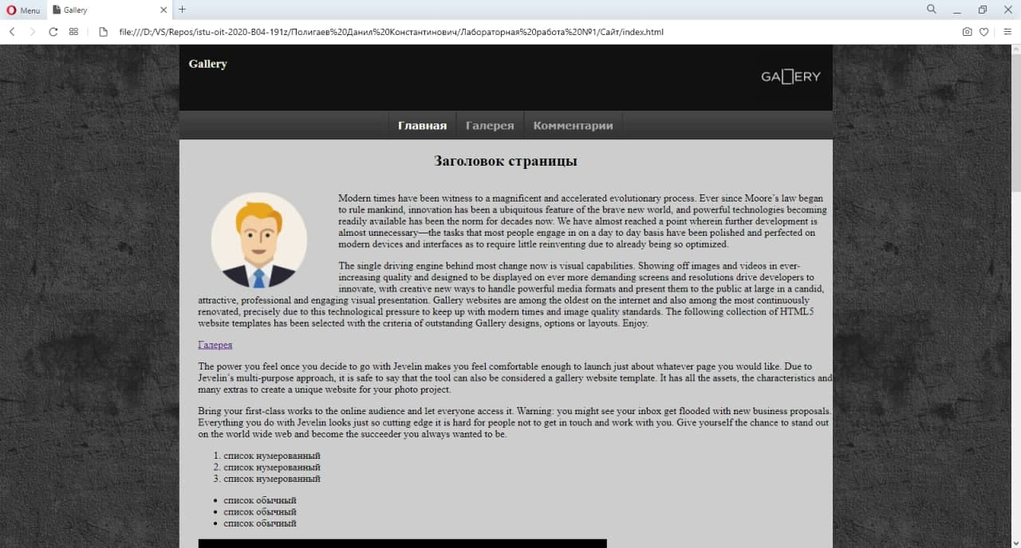

Главное меню (ПК версия).

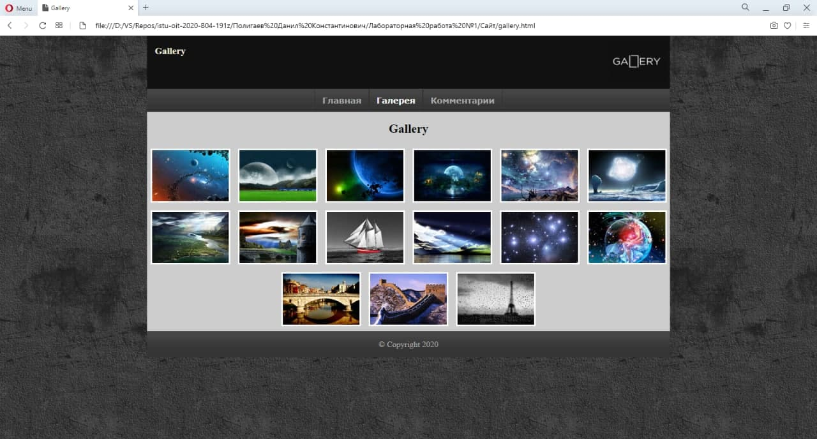

Галерея (ПК версия).

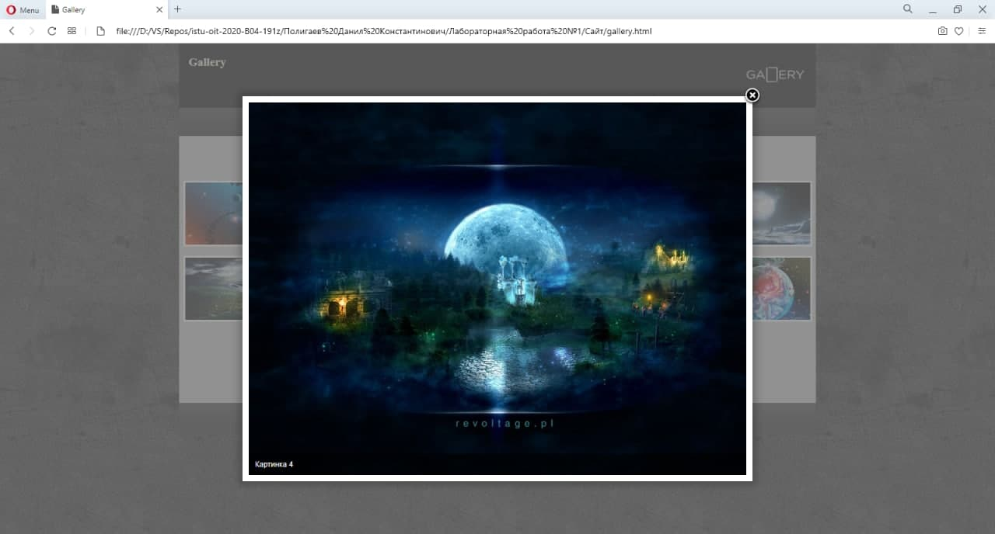

Просмотр изображения (ПК версия).

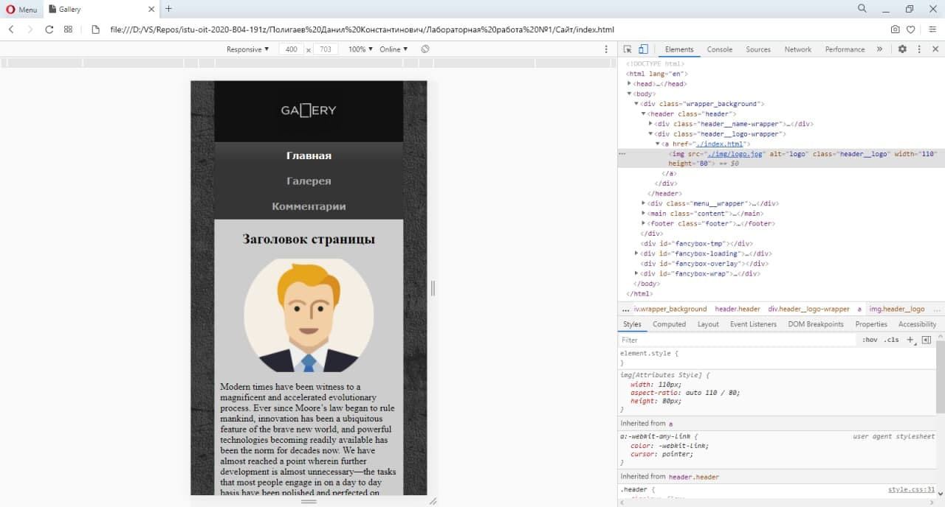

Главное меню (мобильная версия).

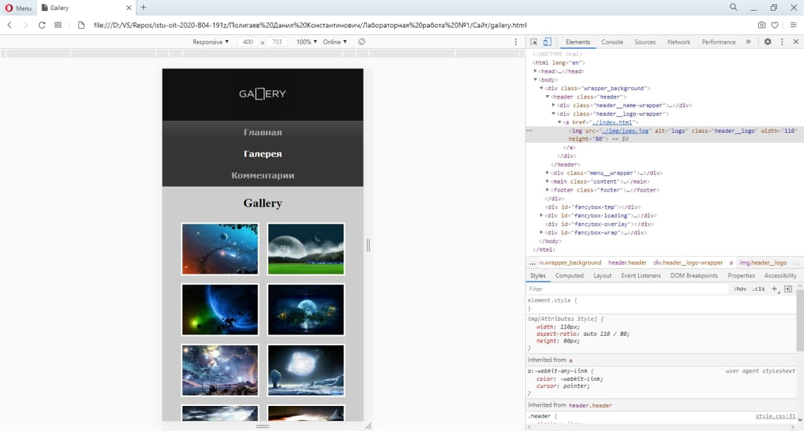

Галерея (мобильная версия).

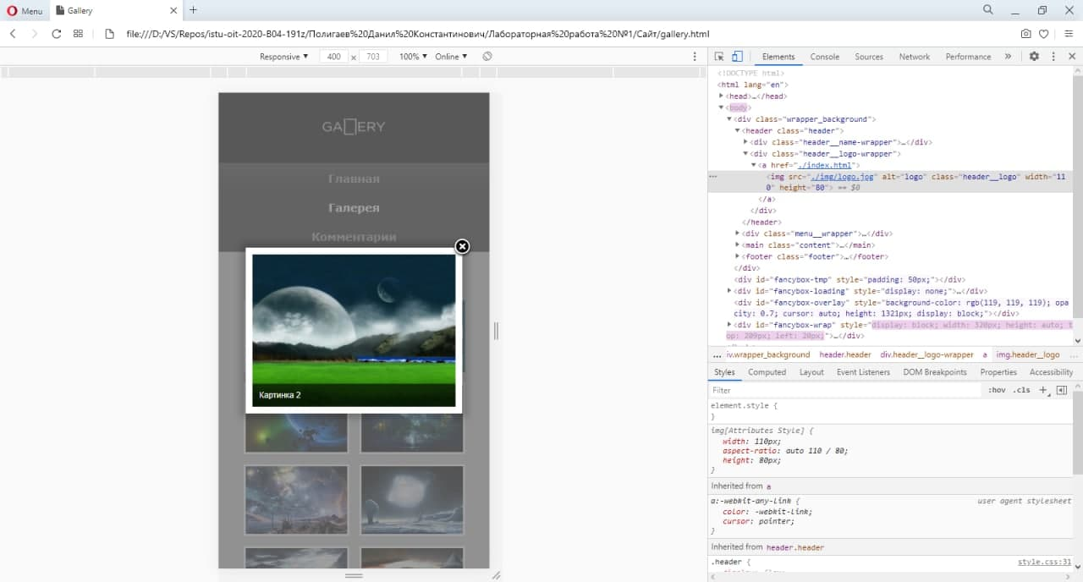

Просмотр изображения (мобильная версия).